For Immediate Release
July 5, 2022
General Contact: Guild of Berkshire Artists - Shany Porras, shany@number5studios.com, 781-439-4330

The Guild of Berkshire Artists hosts Studio Tours in July and August

Pittsfield / Lenox / Great Barrington, MA – The Guild of Berkshire Artists is proud to host its first, post-pandemic Studio Tours since 2019. This year, Guild artists will open their studios to the public on two different weekends across Berkshire County. The first weekend, Saturday and Sunday, July 23rd and 24th will be held in studios in and around Pittsfield and Lenox. The second weekend, Saturday and Sunday, August 20th and 21st, will be held in studios in and around Great Barrington. All public is welcome. For a list of participating artists, media, and their studio addresses please visit The Guild website: www.BerkshireArtists.org.

Event: The Guild of Berkshire Artists Studio Tours 2022

Venue/Location: Various artists’ studios in Berkshire County

Dates/Times: Pittsfield / Lenox Studio Tours
Saturday and Sunday, July 23-24, 2022
11:00 a.m. to 5:00 p.m.

Great Barrington Studio Tours
Saturday and Sunday, August 20-21, 2022
11:00 a.m. to 5:00 p.m.

Detailed Tour Information: www.berkshireartists.org/studio-art-tours-2022

The Berkshire Artists Studio Tours are a great opportunity to learn the processes of local artists in the location where they create! See the processes, equipment, and the tools they use! Get your questions answered about how artists work, their inspiration, and their paths to becoming artists. Artwork will be available for sale by each individual artist in a range of prices. A portion of each sale will go to The Guild of Berkshire Artists, a 501(c)3 nonprofit organization that educates members and the public about art and contributes to the quality of life in the Berkshires.

To learn more about the Guild, please visit www.BerkshireArtists.org
About the Guild of Berkshire Artists

The Guild of Berkshire Artists is a 501(c)3 nonprofit organization that educates members and the public about art and contributes to the quality of life in the Berkshires. The Guild also encourages, supports, and promotes visual artists located in the Berkshires by providing programs such as artists’ talks, live demonstrations, seminars, a monthly newsletter, art openings, Berkshires Plein Air, Berkshire Art Book Gathering, and more. Membership is open to all artists.

Contact: Guild of Berkshire Artists (GBA) – BerkshireArtTours@gmail.com
www.BerkshireArtists.org
info@berkshireartists.org

Key to Featured Photography – See individual photos for download or that are attached separately.
The artist grants permission to use these photos for this press release. (Photo file names start with “GBA”)

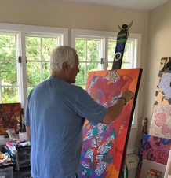 “Guild member Michael Fabrizio in his art studio.”

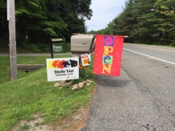 “A Guild artist displays their studio tour signage roadside.”

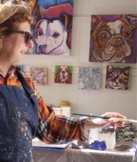 “Guild artist Ilene Richard paints in her studio in Pittsfield.”
(Ilene Richard approved photo on 5/17/2022)
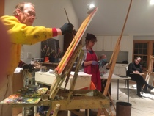

“Kinney Frelinghuysen works with fellow artists in a member’s studio.”
—30—

